**Rolling Element Fault Diagnostics**

**Healthy Bearing Vibration Analysis:**

**Increasing Speed:**

**Dataset #1:**

**Full Time Duration**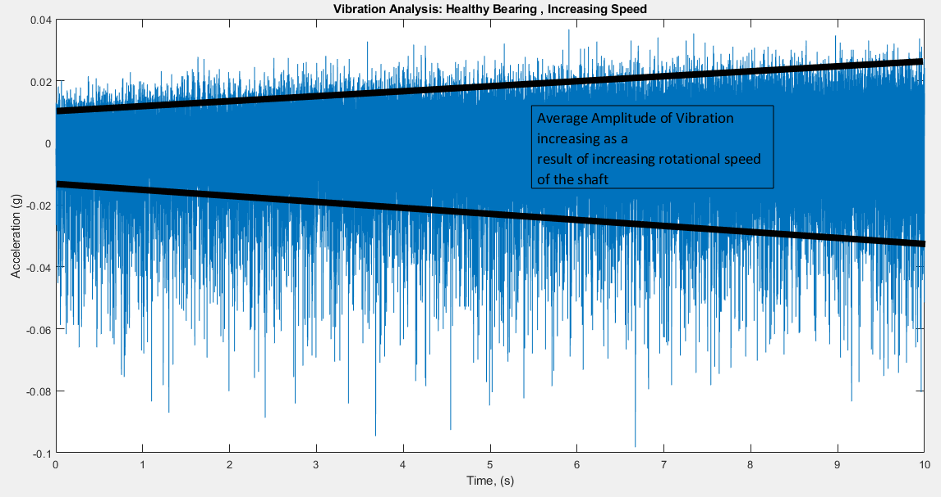

The rotational speed is increased from 14.1 Hz to 23.8 Hz which is almost 2 times increase, this increase is shown in the above graph as well which shows that the amplitude has almost achieved two fold increase.

**Zoomed In View of the Above Graph :**

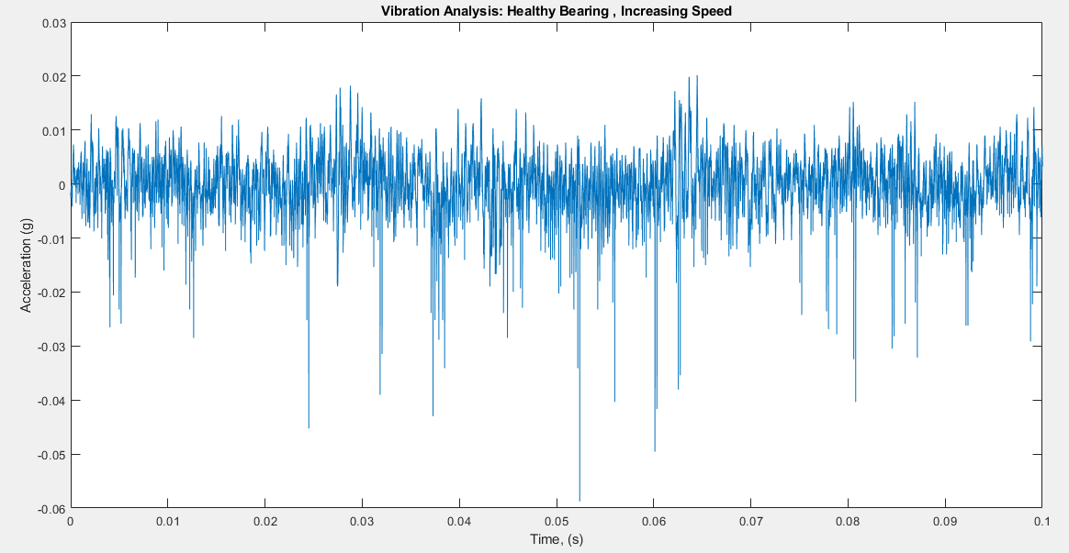

The above graph shows a zoomed in view of the earlier graph from (x =0 🡪 0.1). The graph looks very smooth with only a few anomalies which can be accounted to the increase in rotational speed. Also, the amplitude of the vibration is very small and negligible to cause us a concern.

**Power Spectrum:**

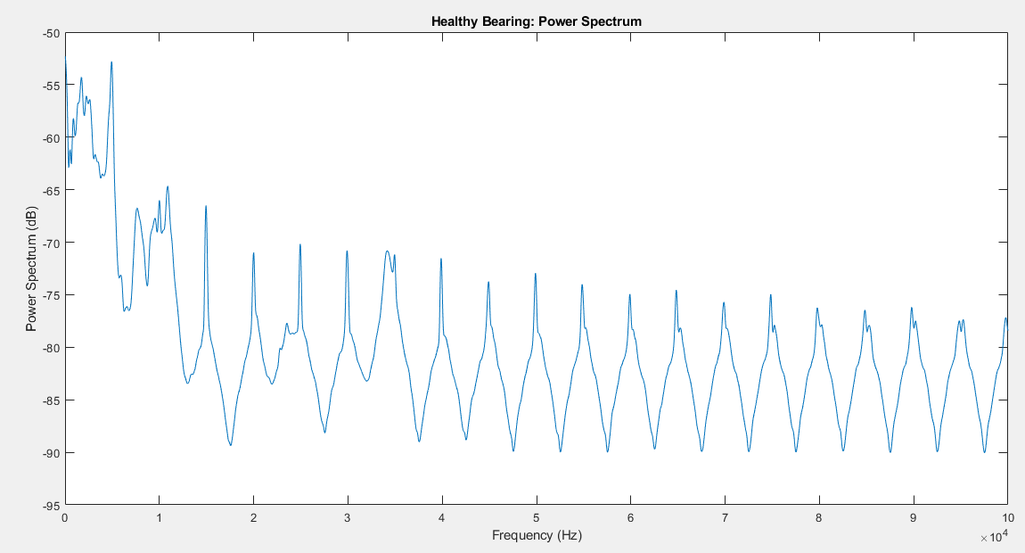

The above graph is Fast Fourier Transform of the bearing signal which shows very minute variations and is generally very repetitive. The no. of peaks at increasing frequencies are due to the increase in rotational speed of the shaft.

**Envelope Spectrum Analysis**

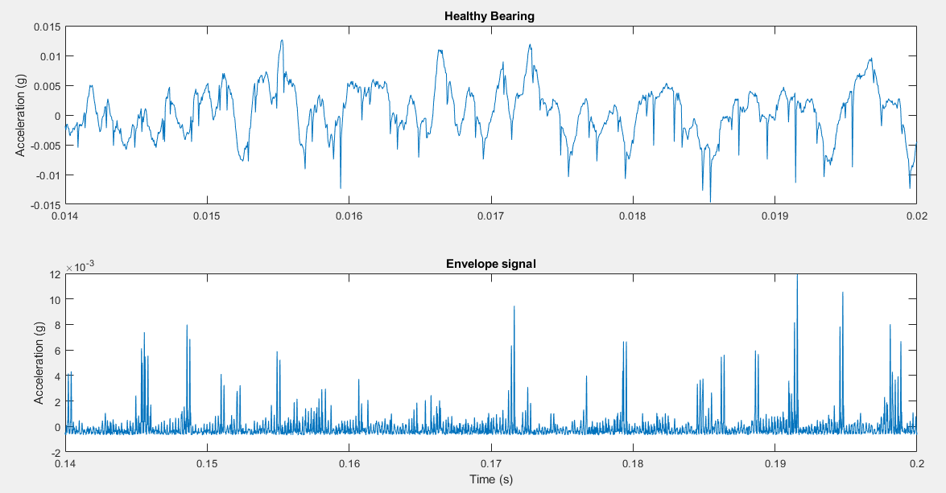

The envelope spectrum analysis of the vibration data of the healthy bearing is a procedure with which we can seclude the original vibration of the data from the surrounding noise data that may be accumulated in the results to contaminate the original data.

The graph below displays the waveform that we obtain after doing the envelope spectrum. It is clearly shown in the graph that no particular harmonics are present at either the BPFO or BPFI, it is a testimony that the bearing under consideration is a healthy one.

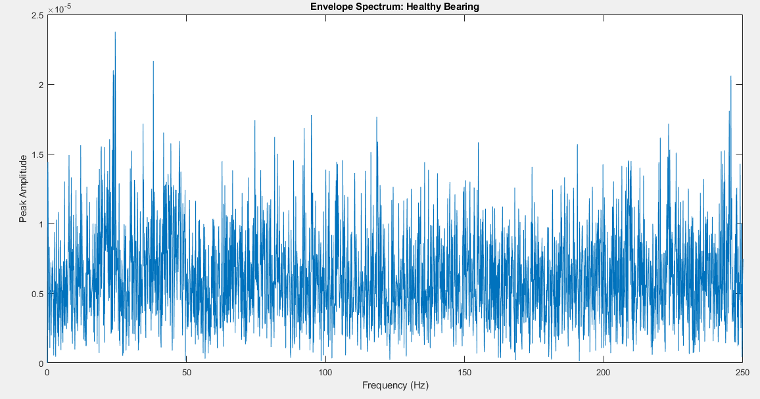

**Inner Race Fault, Bearing Vibration Analysis:**

**Increasing Speed:**

**Dataset #1:**

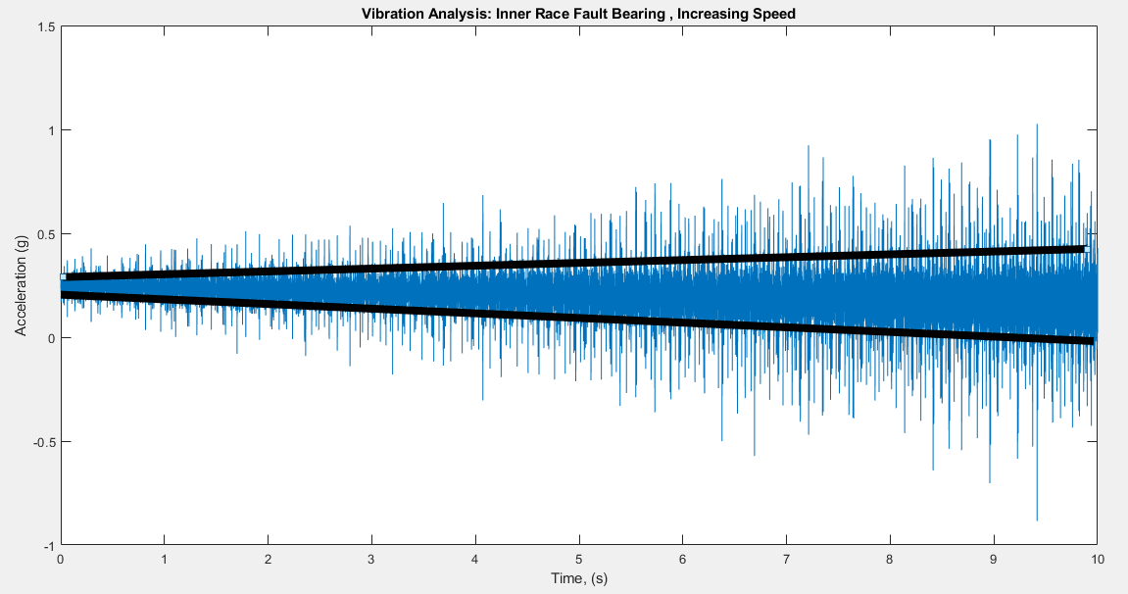

The graph provided above is the time domain plot of vibration of a bearing with an inner race fault with increasing rotational speed. As we can see that the amplitude seems to be rising due to the increase in speed but it is rising at an exaggerated rate and extent due to the inner race fault in the bearing as by each passing revolution, the inner race hits the shaft.

**Zoomed In view:**

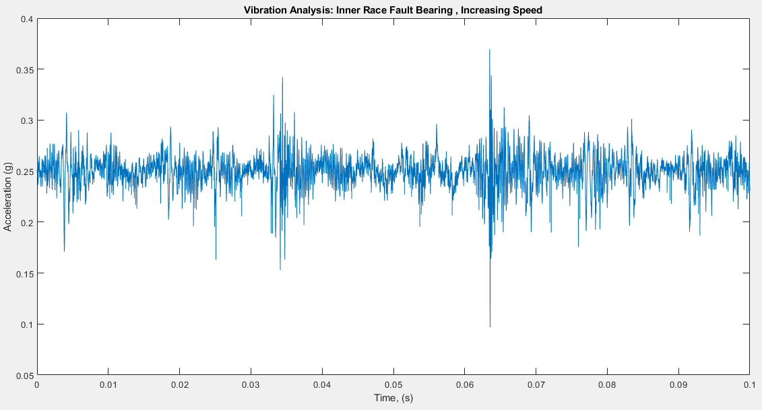

The zoomed in view shows a much better picture and tells us that there is some definite abnormality between the vibration as it was not visible in the healthy bearing analysis.

**Power Spectrum:**

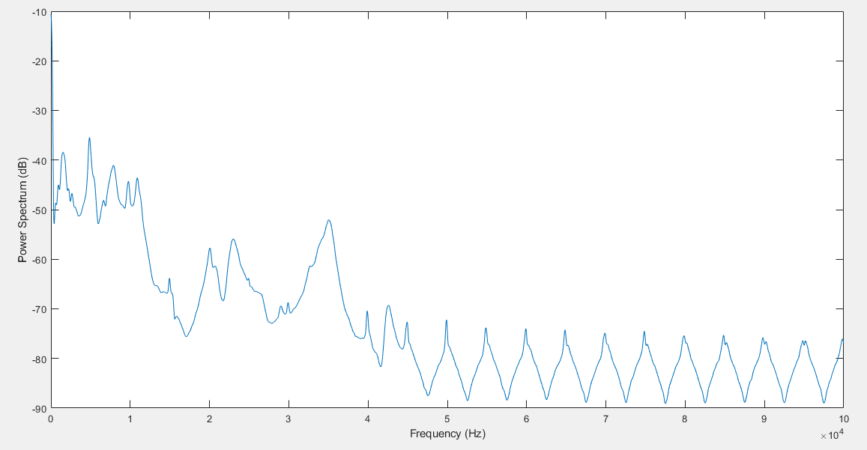

The above graph is Fast Fourier Transform of the bearing signal which shows drastic variations. This can be attributed to it being contaminated by unwanted frequencies due to the inner race fault in the bearing.

**Envelope Spectrum Analysis**

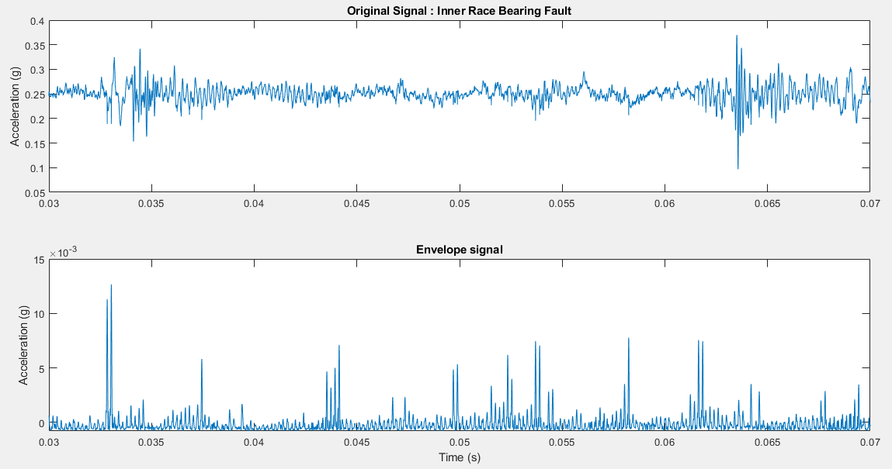

The below graph shows that the bearing with the inner race fault has more energy focused on the BPFI and its harmonics. It bares no resemblance to the power spectrum analysis down on a normal, healthy bearing.

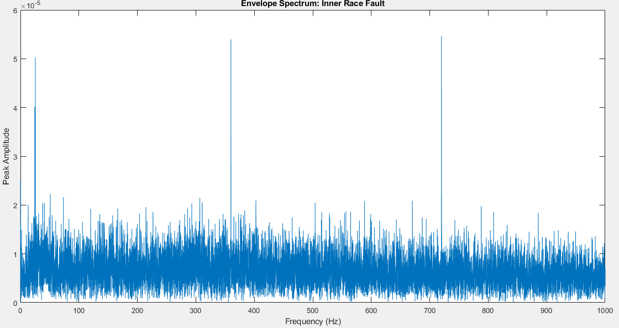

Kurtosis Analysis:

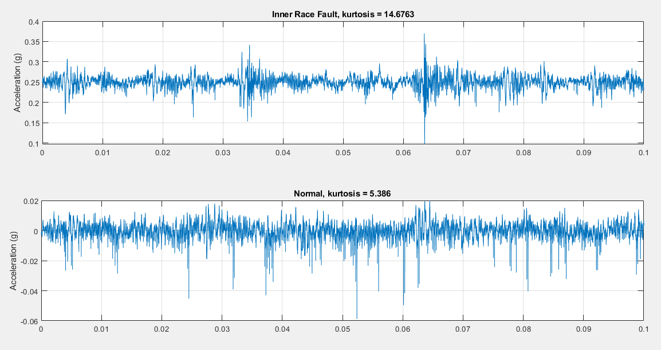

It is shown that inner race fault signal has significantly larger impulsiveness, making envelope spectrum analysis capture the fault signature at BPFI effectively.